Real simple process.  You have a second link for pre-registering

visitors:  <https://secure.safevisitorsolutions.com/Safe/Visitor/franklin000012>

This is great for events like grandparents day, meetings etc.

Go ahead and login yourself in and walk through it to see how easy and quick it is.  For attendants they will quickly review in queue, click login arrow, take phone and print badge…15 seconds.

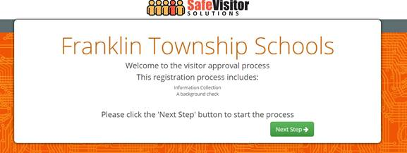

Visitor enters their info:

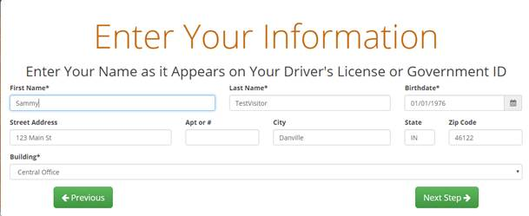

Visitor inputs who visiting.  The visitors will only show on attendants screen the day they are visiting.  If visitor knows email and/or mobile phone of person visiting they can add that and when they check in it will send a text and/ or email to them to let them know visitor has arrived.

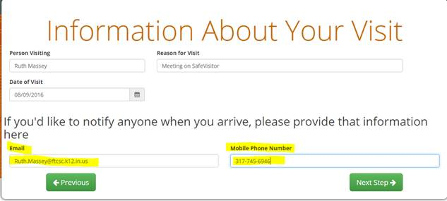

Visitor clicks Complete Request

